

CS 305 Project Two
Practices for Secure Software Report

Table of Contents

Document Revision History
Client
Instructions
Developer
1. Algorithm Cipher
2. Certificate Generation
3. Deploy Cipher
4. Secure Communications
5. Secondary Testing
6. Functional Testing
7. Summary

Document Revision History

Version | Date | Author | Comments
1.0 | 02/25/2022 | Alice Norris

Client



Developer
Alice Norris

1. Algorithm Cipher

Two encryption algorithm ciphers were chosen, namely, TLS_ECDHE_ECDSA_WITH_AES_256_CBC_SHA and TLS_ECDHE_RSA_WITH_AES_256_CBC_SHA. These were chosen because they use ECDHE and DHE for key exchanges, as they provide forward secrecy. Even if the keys were compromised, previously sent messages could not be decrypted in the case of an attack recording messages in the hopes of decrypting them later. The AES cipher uses a key size of 256 bits, and in CBC mode each block processed is modified by the block that comes before it, mutating each, preventing identical blocks of repeated data from having the same cipher. ECDHE is a mechanism by which keys can be exchanged over an insecure channel. The CBC mode specified also uses a random number for the data blocks of 128 bits each, padding as necessary, further obfuscating the data. ECDSA is used for authentication in the first, and RSA is used in the second. AES-256 is used with a CBC mode to encrypt the data, and SHA is used as the hashing algorithm. AES is symmetrical, meaning that the same key is used on both sides of the transaction: both encrypting and decrypting.

The first widely adopted block cipher akin to the ones used today, the Data Encryption Standard (DES), was developed in the 1970s at IBM. However, as computational power grew, it became easier to discover patterns and weaknesses in early block ciphers. However, it is easier to encrypt data with known keys than it is to try to discover and break patterns in encrypted data. This resulted in a sort of “arms race”, involving increasingly complex and clever patterns being used in ciphers, followed by attackers attempting to break them. At a certain point, however, it became feasible to create encryption methods that were nearly immune to brute-force attacks, requiring attacks on stored keys, discovering weaknesses in implementation, and intercepting encrypted communications before they were well-established. For example, AES 256 is still considered secure as brute-force would require attempting every key possible. Since each bit has two possible values, being binary, it would require 2²⁵⁶ attempts to perform an exhaustive search, requiring a prohibitive number of attacks. It is far easier to attempt to compromise keys or perform another sort of attack entirely to break them.

2. Certificate Generation
To demonstrate that the keys were effectively generated using the Java Keytool, a screenshot of the exported certificates (CER file) have been provided below.

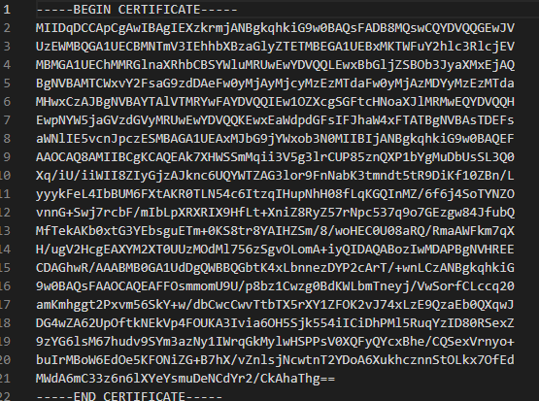

3. Deploy Cipher
Below is a screenshot of the checksum verification using the author’s name.

4. Secure Communications
Below is a screenshot of the web browser showing secure communication with server after refactoring code to use HTTPS instead of HTTP.

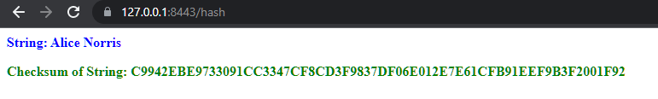

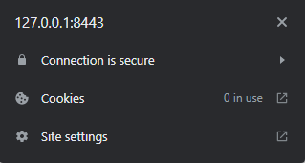

5. Secondary Testing
The refactored code executed without error using the Maven test goal can be seen successfully built here:
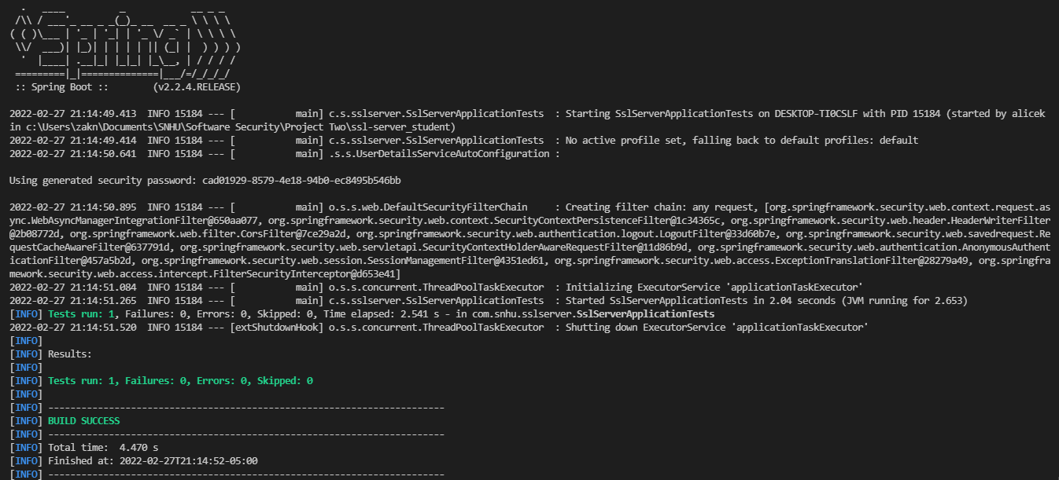

6. Functional Testing
The dependency vulnerability chart returned after all refactoring was complete is as follows:

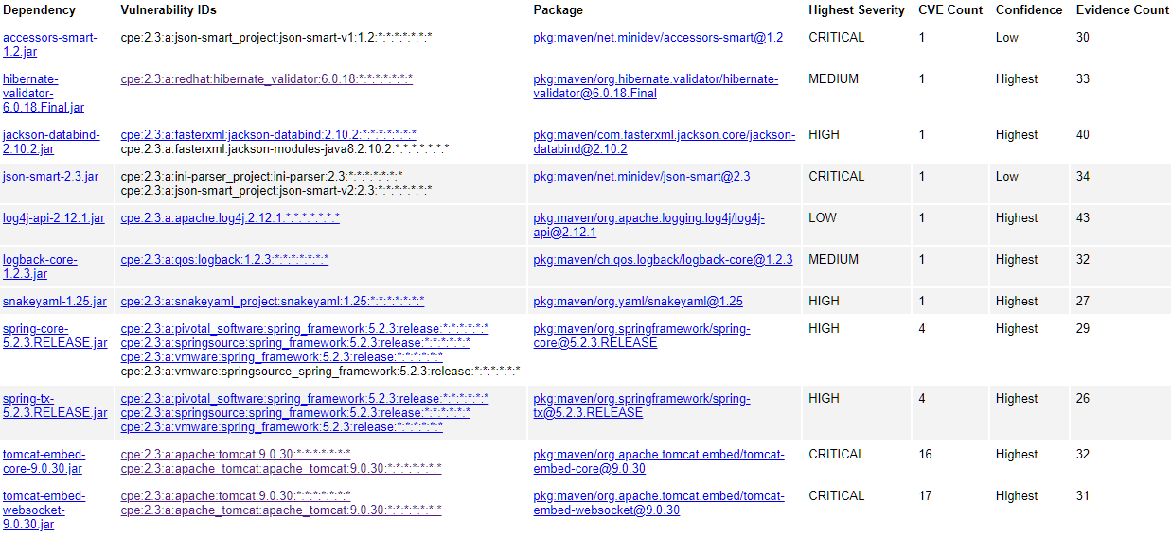

The dependency vulnerability report generated by running the codebase in its unaltered state has the same dependencies reported with the same vulnerability count:
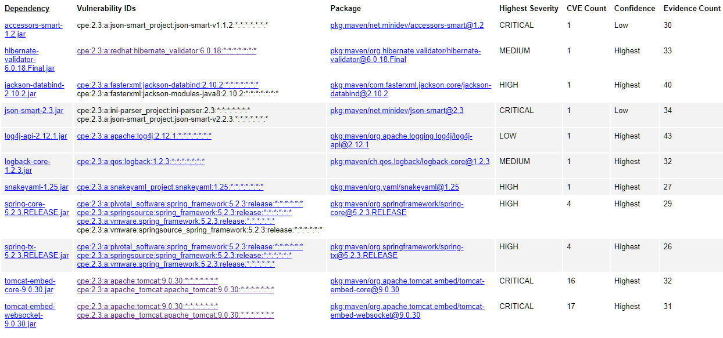

No new vulnerabilities have been introduced by my code.

7. Summary
Following the vulnerability assessment diagram accompanying this report, I addressed cryptography issues by selecting TLS version 1.2, and choosing an appropriate cipher suite, implementing suites capable of appropriately strong encryption, including forward secrecy. Secure Distributed Composition was also implemented by securing individual aspects of the system, as the overall security of a system is only as strong as its weakest component. Any file and cryptographical functions that can throw errors related to the environment or input/output issues are handled gracefully. Encapsulation was achieved by segmenting functionalities into appropriate components. The hash endpoint handles security internally, application-wide security configuration is done in its own class by extending automatically configured properties, and options are set as needed in configuration files, including application.properties and in the pom.xml file. These changes can be seen in the code files attached along with the report.

Security layers were added incrementally, first by implementing commonly used best practices, such as using properly configured self-signed certificates, securing the certificates used to authenticate the server, and selecting an appropriate cryptographic suite for TLS to allow encrypted transfer of data. Data that is transferred by the TLS-secured channel are protected from alteration at rest or en-route by providing checksums of data, using the SHA-256 algorithm, which is highly unlikely to be compromised by furnishing manipulated data with a key that collides with the checksum of the original, unaltered data. Common HTTP/2 security protocols are implemented using the Spring framework’s security dependency, which protects against XSS, CORS, and other spoofing or MITM type attacks.

To achieve security, several dependencies required specifying version numbers in order to maintain compatibility with existing dependencies while also minimizing vulnerabilities. Dependency checks should be run regularly in order to provide fixes to new vulnerabilities as they appear, and all versions should be kept as up-to-date as possible. If proper versioning and code maintenance are done at regular intervals, including automated checks for new vulnerabilities, the code should remain secure.

